

|  |  |  |  |
| --- | --- | --- | --- |
| Project Information | | | |
| Project Title | CSCC01 Project (Course tutoring network) | | |
| Start Date | September 25/2012 | **End Date** | December 3/2012 |
| Institution | University of Toronto | | |
| Project Director | Dr. Hesam C. Esfahani (hesam@cs.toronto.edu) | | |
| Course Name | CSCC01 – Introduction to Software Engineering | | |

|  |  |
| --- | --- |
| Document Name | |
| Document Title | Project Plan |
| Authors | Rui Tang, Pedro Tobo, Wynn Wong (Group 12) |
| Date | October 2012 |

|  |  |  |
| --- | --- | --- |
| Document History | | |
| Version | **Date** | **Comments** |
| V 1.0 | October 10, 2012 | First issue |
|  |  |  |
|  |  |  |

Introduction

Course tutors are one of the principals service students use to succeed in university courses but at the same time it becomes one of the hardest resources to find, due to the nature of this service, locate reliable tutors and verify their quality is very difficult. On the other hand for tutors locate students looking for their services is usually done by no extremely interactive means like pinboards and billboards, interaction between them and potential clients could be improved.

A collaborating system where students and tutors can meet and students can verify potential tutors qualifications and find feedback for previous students will improve student access to this convenient academic resource. At the same time tutors could find their potential clients and schedule their appointments quicker and more precise

Project organization

Our development team can make this project a success. We have the experience and knowledge in software development projects and can support this process every step of the way. Our team members are:

Pedro Tobo

Pedro has a wide experience as a designer, analyst, programmer and consultant for information technologies, excellent ability to interface with management and the users and poses strong analytical skills combined with experience in many programming languages like PHP, C# and Ruby. His experience as a team player has given him the ability to complete project cycles, testing and final implementations. His expertise is extensive in the creation, analyzing and implementation of web-based products.

Rui Tang

Ray has extensive experience in system testing through the previous co-op work terms. He was involved in drafting test cases, extensive system testing and preparing detailed defect reports. He also gains valuable experiences in requirement engineering through one summer internship, acted as both business analyst and programmer, communicating with real customers and making a program tailored to their needs. He is familiar with Java, Python, VBA and VB script. Combined with great teamwork spirit, he will collaborate with the team members to make sure the team is building the product right and the client has the right product.

Wynn Wong

Hardware and software requirements

Our application is planned to be a fully web-based application and uses web browser as user interface. No other client software is required.

Web-browser requirements

Our application can be accessed from any device with one of the next browsers:

* Microsoft Internet Explorer version 8.0 or later
* Mozilla Firefox version 10 or later
* Apple Safari version 5 or later
* Google Chrome version 17 or later

Server software requirements

Our application could be installed on any operating system with a web server which supports PHP 5.3 or later

Database requirements

Our application should be hosted by any database server running MySQL 5.1 or later

Technological options

For the development of the application we decided PHP is the best option as a language, since it is a web-based application we looked for a secure web platform, fast and reliable and with its community support and our team expertise on this language it becomes the natural decision. As a framework Zend framework 2.0 is our best option because it is an official framework it has commercial support, which guarantee us assistance on possible problems down the road

Resources needed

In the development process just open source tools will be used, leaving us with only with the hardware costs but in this particular case the development team will supply those hardware requirements.

Schedule

Project Activities

|  |  |  |  |  |  |
| --- | --- | --- | --- | --- | --- |
| ID | Activity | Start Date | Duration | Depends On | Status |
| 1 | Project plan writing | 12-09-26 | 10 days |  | Completed |
| 2 | User stories definition | 12-09-27 | 3 days |  | Completed |
| 3 | User stories detailing | 12-10-02 | 4 days | 2 | Completed |
| 4 | User stories writing | 12-10-08 | 5 days | 3 | Active |
| 5 | Database design | 12-10-16 | 4 days | 20 | Active |
| 6 | Signing up module | 12-10-18 | 3 days |  | Active |
| 7 | Courses creation module | 12-10-23 | 4 days | 6 | Active |
| 8 | Find courses module | 12-10-24 | 2 days | 6 | Active |
| 9 | Tutor rating and comments | 12-10-30 | 4 days |  | Active |
| 10 | Course rating and comments module | 12-10-30 | 4 days |  | Active |
| 11 | Course registration module | 12-10-30 | 2 days |  | Active |
| 12 | Notification module | 12-10-30 | 5 days |  | Active |
| 13 | Publishing schedule | 12-11-07 | 4 days |  | Active |
| 14 | Schedule availability | 12-11-07 | 6 days |  | Active |
| 15 | Test plan | 12-11-09 | 12 days |  | Active |
| 16 | Deployment plan | 12-11-27 | 5 days |  | Active |

Milestones

|  |  |  |  |  |
| --- | --- | --- | --- | --- |
| ID | Title | Depends On | Status | End Date |
| 1 | Project plan | 5 | Completed | 12-10-10 |
| 2 | User stories | 4 | Active | 12-10-15 |
| 3 | Deliverable 1 | 8, 5, 7 | Active | 12-10-29 |
| 4 | Deliverable 2 | 12, 11, 9, 10 | Active | 12-11-06 |
| 5 | Deliverable 3 | 13, 14 | Active | 12-11-15 |

Iterations

|  |  |  |  |
| --- | --- | --- | --- |
| ID | Title | Start Date | End Date |
| 1 | Iteration 1 | 12-09-26 | 12-10-29 |
| 2 | Iteration 2 | 12-10-29 | 12-11-06 |
| 3 | Iteration 3 | 12-11-06 | 12-11-15 |

Initial Gantt chart

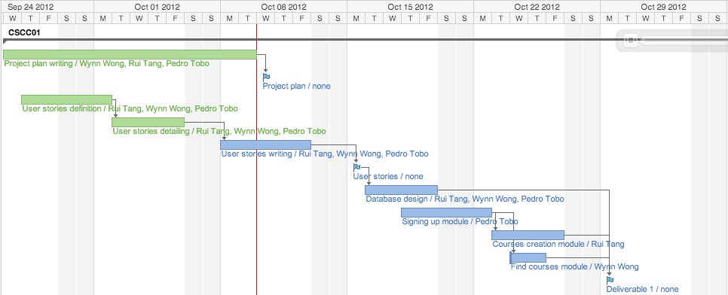

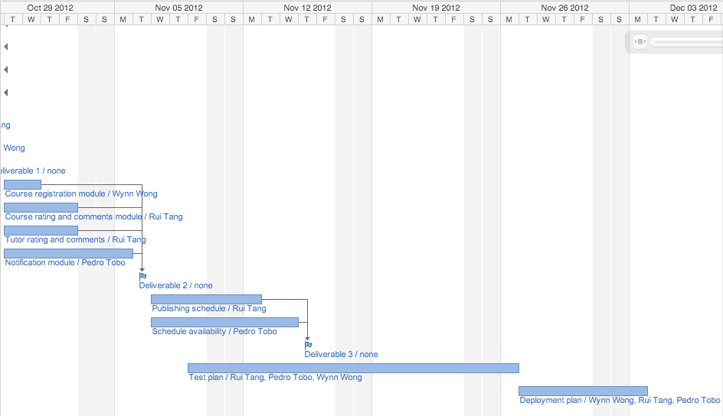

Initial staff allocation chart

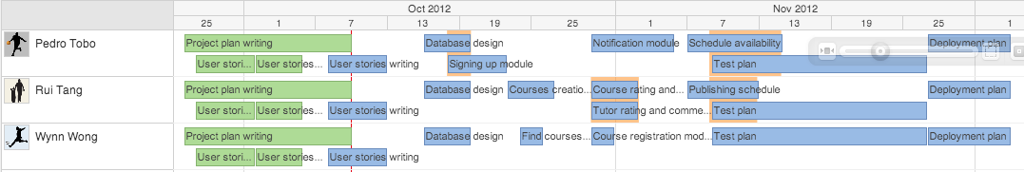

Risk Analysis

1. **Less productivity in the early stage** of the project due to procrastination.
2. **False assumption/expectation of team members’ ability** thus cannot deliver the promised results on time
3. **The priority of the project** might be altered due to exams or job interviews, not able to get the key deliverables from one or many group members.
4. **Lack of man power** in the team in the beginning to start with, out of six people on the group information sheet, we are left with only 3 members, to finish 4 or 5 people’s job.
5. Key member(s) of the team become ill and unable to meet deliverables.
6. Key member(s) of the team drop the course.
7. Lacking of the programming knowledge. Not everyone is familiar with the language we used in this project (PHP, in this instance).
8. Continue with the above point, required training/knowledge transfer is not available or is insufficient.
9. Lack of documentations on the job that each group member has done, impossible for others to continue the job in the case of emergency.
10. Team members don’t get along, no spirit of teamwork.
11. Different expectations/motivations of the team members from the course, some people try to be a 4.0 student, where as an average B will serve well for the rest of the group.
12. Low morale among the team member(s) due to dry and boring course material.
13. The course instructor/TA changes during the term.
14. Failed to understand client’s intention, such as gathered false requirements or didn’t correctly prioritize the client’s needs.
15. False assumption of the size of this project, underestimate the time required to complete the project.
16. Change of the core requirements from the client half way through the project.
17. The decided programming language (PHP in this case) cannot meet the client’s requirements; change to other programming languages half way through the project.
18. Loss of files due to laptop theft, robbery, or fried hard drive without the latest back up.
19. Online repository (github in this case) shut down
20. Natural disaster, snowstorms shut down the campus for two weeks, harder to keep group members on the same page without in-person meetings, delaying key project milestones.

|  |  |  |  |  |  |  |
| --- | --- | --- | --- | --- | --- | --- |
| # | Risk Description | Risk Type | Likelihood | Effect severity | Risk Strategy | Type of Strategy |
| 1 | Less productivity in the early stage of the project due to procrastination | Estimation | Very high | Tolerable | Have a draft project plan early in the stage, so people have a rough sense of time restrictions | Avoidance |
| 2 | False assumption/expectation of team members’ ability thus cannot deliver the promised results on time | People | High | Tolerable | A brief meeting with possible teammates beforehand to assess their ability | Minimization |
| 3 | The priority of the project might be altered due to exams or job interviews, not able to get the key deliverables from one or many group members | People | Very high | Tolerable | Share a tracking log with each member's responsibilities and their progress. Increase the job overlap | Minimization, Contingency |
| 4 | Lack of man power, less than 4 people in the group | People | Moderate | Tolerable | Discuss with other class mates trying to take one or two extra people in. If not possible, existing group members need to take on extra work load | Contingency |
| 5 | Key member(s) of the team become ill and unable to meet deliverables | People | Moderate | Serious | Share a tracking log with each member's responsibilities and their progress. Increase the job overlap | Minimization, Contingency |
| 6 | Key member(s) of the team drop the course | People | Moderate | Serious | Share a tracking log with each member's responsibilities and their progress. Increase the job overlap | Minimization, Contingency |
| 7 | Lacking of the programming knowledge. Not everyone is familiar with the language the team decided to implement | People | Moderate | Tolerable | Take this into account during the project planning and scheduling stage. Set up extra hours between the group members to facilitate the knowledge transfer process | Minimization, Contingency |
| 8 | Continue with the above point, required training/knowledge transfer is not available or is insufficient | People | Moderate | Serious | Take this into account during the project planning and scheduling stage. Set up extra hours between the group members to facilitate the knowledge transfer process | Minimization, Contingency |
| 9 | Lack of documentations on the job that each group member has done, impossible for others to continue the job in the case of emergency | People | High | Serious | Share a tracking log with each member's responsibilities and their progress. Increase the job overlap | Minimization, Contingency |
| 10 | Team members don’t get along, no spirit of team work | People | Moderate | Catastrophic | Need a team leader to facilitate the communication and unite the group together | Contingency |
| 11 | Different expectations/motivations of the team members from the course, some people try to be a 4.0 student, where as an average B will serve well for the rest of the group | People | Moderate | Tolerable | Set a common goal at the beginning and communicate to all the group members to make sure everyone is on the same page | Avoidance |
| 12 | Low morale among the team member(s) due to dry and boring course material | People | Low | Tolerable | Need a team leader to facilitate the communication and unite the group together | Contingency |
| 13 | The course instructor/TA changes during the term | Organizational | Very low | Catastrophic | Have the most up to date version of the project and convince the new instructor/TA to keep the same requirements and course evaluation breakdown | Contingency |
| 14 | Failed to understand client’s intention, such as gathered false requirements or didn’t correctly prioritize the client’s needs | Requirements | Low | Catastrophic | Implement the "Incremental Development" software process, receive client's feedback on every step | Avoidance |
| 15 | False assumption of the size of this project, underestimate the time required to complete the project | Estimation | High | Serious | Set a fake/earlier project deadline to work with. Leave extra room for the unexpected | Avoidance |
| 16 | Change of the core requirements from the client half way through the project | Requirements | Low | Catastrophic | Implement the "Incremental Development" software process, receive client's feedback on every step | Avoidance |
| 17 | The chosen programming language cannot meet the client’s requirements; change to other programming languages half way through the project | Technology | Low | Catastrophic | Investigate the requirements of the clients before choosing the tool | Avoidance |
| 18 | Loss of files due to laptop theft, robbery, or fried hard drive without the latest back up | Estimation | Very low | Catastrophic | Back up, back up, backup | Avoidance, Minimization |
| 19 | Online repository (github in this case) shut down | Tool | Very low | Catastrophic | More back ups | Avoidance, Minimization |
| 20 | Natural disaster, snow storms shut down the campus for two weeks, harder to keep group members on the same page without in-person meetings, delaying key project milestones | Estimation | Moderate | Insignificant | Utilize the msn, phone calls and web conference opportunities and let everyone stay in touch | Minimization, Contingency |